Analyze Korea DBQ
Objectives
- Students will analyze a variety of documents to demonstrate their understanding of Korea.

Time
- one or two class periods

Level
- high school

Procedures
- Select ten of the documents provided or find others using online resources.
- Teachers may choose to allow students a day to analyze the documents and a day to write an essay depending on the skills developed at the time of lesson.
- Teachers should set expectations for the essay depending on course goals such as how many documents may be required and how these should be cited.
- Teachers may want to allow students to select one of the following topics or only provide one.

- Compare and contrast North and South Korea.
- Analyze to what extent North and South Korea represent the evolution of communism and capitalism.
- What do the differences between North and South Korea demonstrate about the nature of development?

Differentiation
- The level of difficulty can be increased by requiring that the document analysis and essay be completed in the same class period or by requiring at least 6 documents be used as evidence in the essay.
- The level of difficulty can be decreased by allowing students a day before the essay to analyze the documents or by providing guidance to analyze them. The difficulty can also be decreased by requiring fewer documents or a shorter essay.

Sources and Resources

http://www.dailytitan.com/wordpress/wp-content/uploads/2010/05/20100524_N_Korea_trade.jpg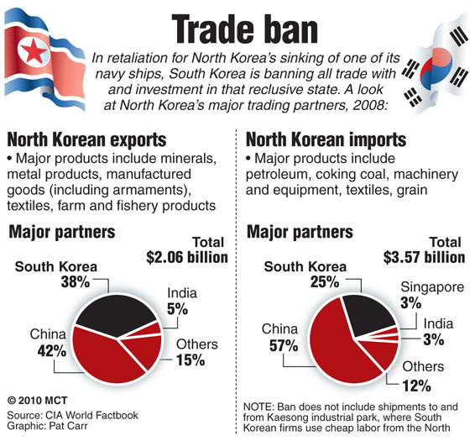
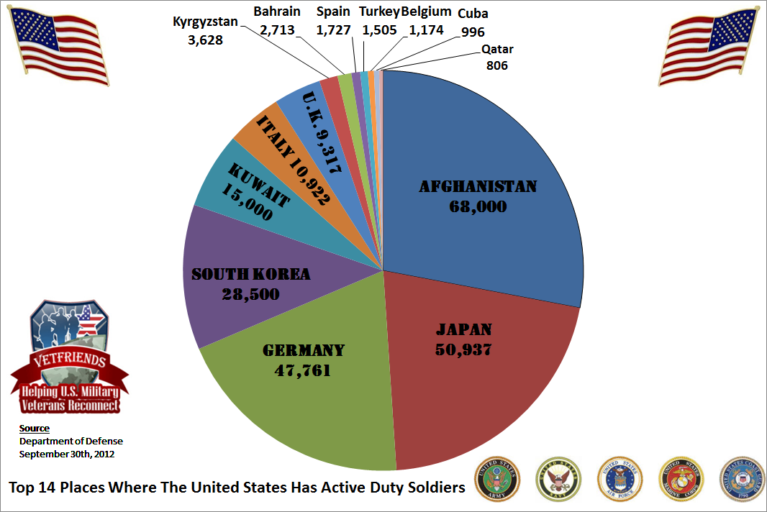
https://www.vetfriends.com/images/Top%2014%20Places%20to%20Find%20Troops%202012.png

The Organisation for Economic Co-operation and Development’s triennial international survey compared test scores from 65 countries. Happiness was ranked based on the percentage of students who agreed or disagreed with the statement “I feel happy at school.” Test scores were ranked based on the combined individual rankings of the students’ math, reading, and science scores.
visual: Jake Levy, Data Analyst at BuzzFeed
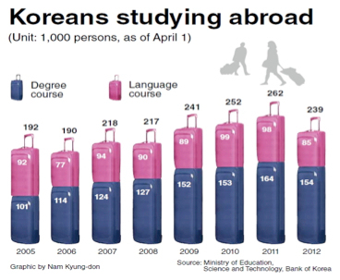
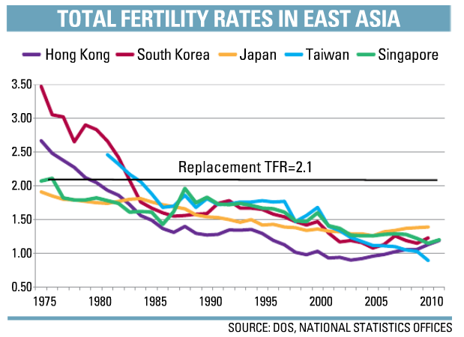
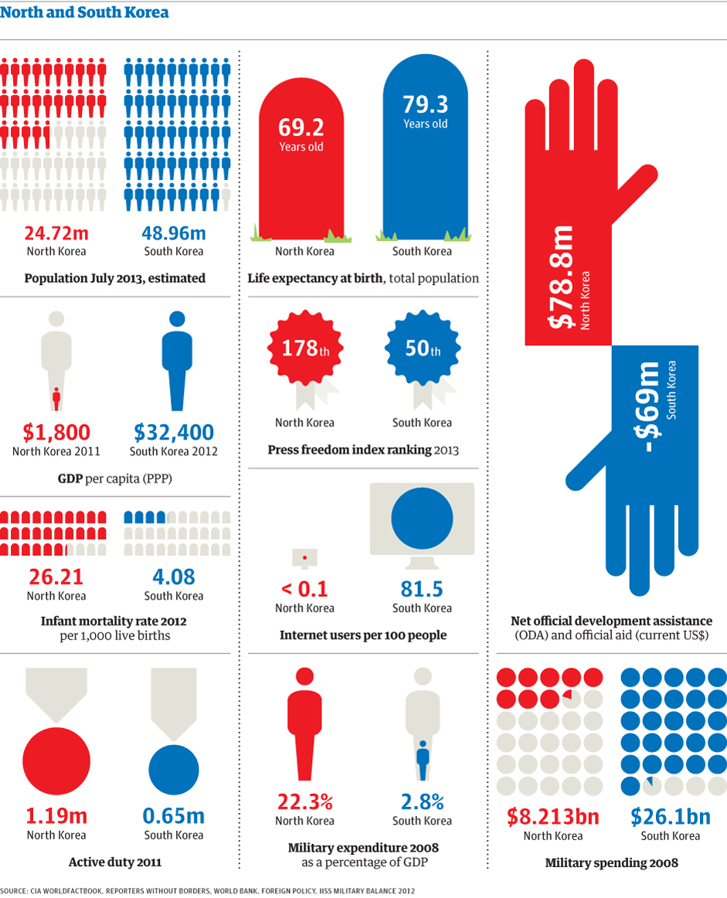
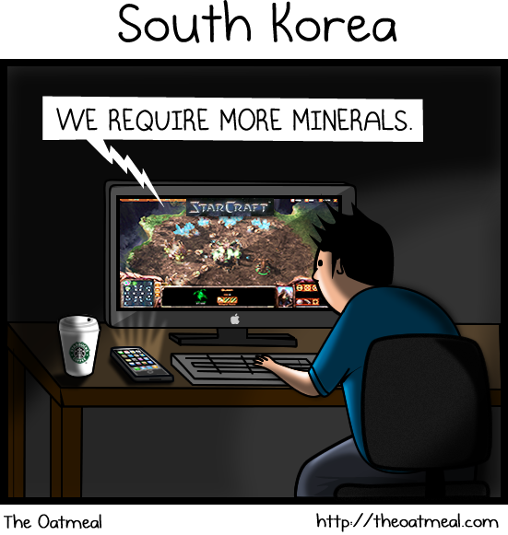
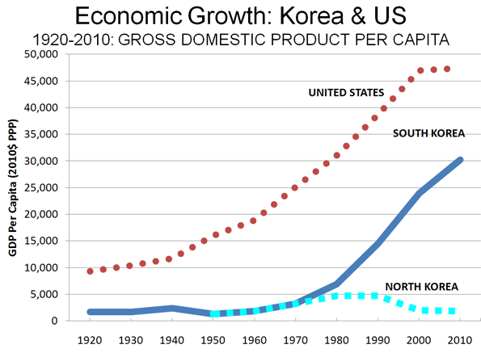
http://www.newgeography.com/content/002060-the-evolving-urban-form-seoul

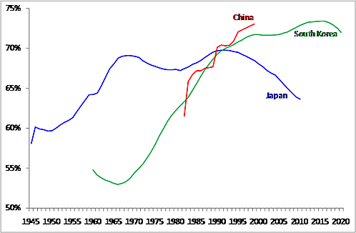
http://www.ide.go.jp/English/Research/
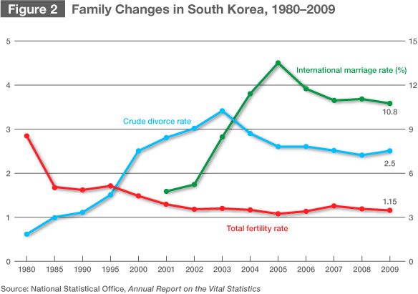

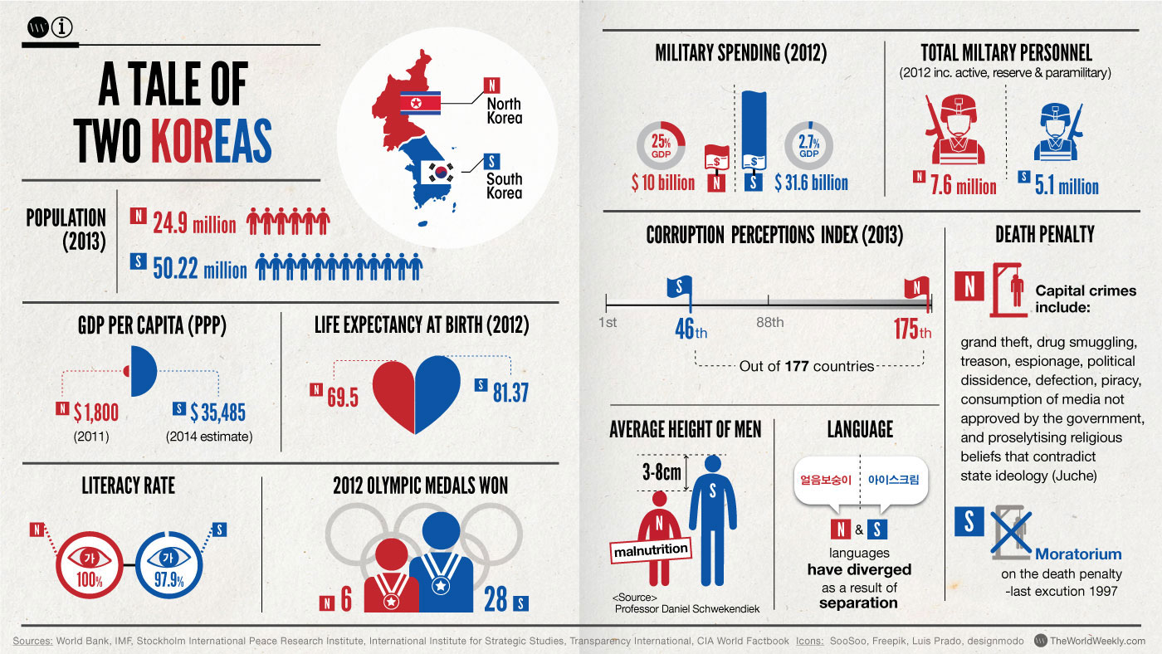
http://media.economist.com/images/images-magazine/2010/10/IR/201010IRD003.jpg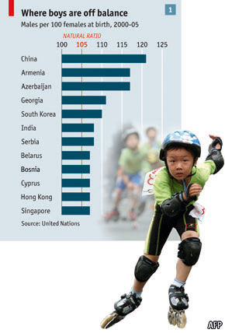
http://cdn.static-economist.com/sites/default/files/imagecache/original-size/images/print-edition/20131207_ASC885.png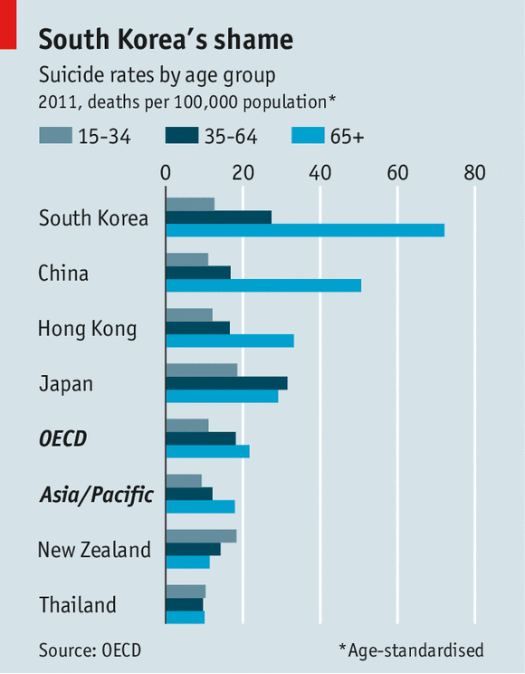

earthobservatory.nasa.gov
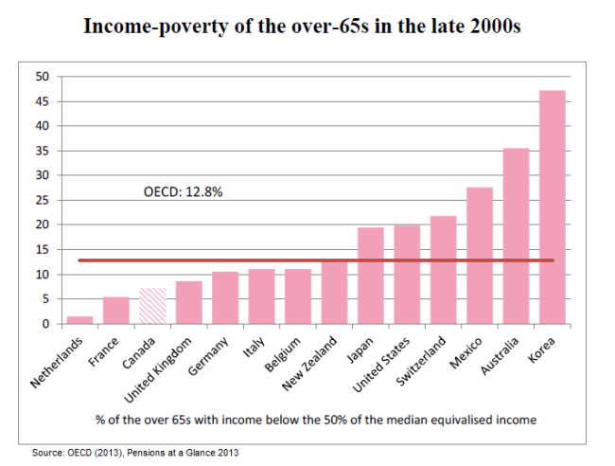
https://sunlifebrighterlife.files.wordpress.com/2013/11/kp205_senior-poverty-rates.png?w=650&h=492

